Renefred Jean Charles
Linux Administration Portofolio
Spring 2026
Northern Essex Community College

About me
I am a Computer Science and Information Technology student at Northern Essex Community College with a strong interest in cybersecurity and data science. I am currently developing hands-on experience across multiple areas of technology, including Linux administration, scripting and server security.
My goal is to become a Cybersecurity Engineer and Data Scientist, combining analytical thinking with technical problem-solving to protect systems and extract meaningful information from data. I am eager to learn, adapt, and apply new concepts in real-world environments.
I am committed to contributing to team success while continuously improving both my technical and communication skills. I am passionate about building a long-term career in technology, solving complex problems, and making a meaningful impact in the digital world.
I am fluent in English, French, Creole.
I plan to transfer to University of Montreal or Concordia University to pursue a bachelor degree in Computer Science.

Contact Information
Email : 00343836@student.necc.edu
LinkedIn:https://www.linkedin.com/in/renefred-jean-charles-358953304?utm_source=share_via&utm_content=profile&utm_medium=member_android
Github:https://github.com/Fred2709/Linux-Administration-Portofolio/edit/main/README.md

Lab 1 – Server Setup
This lab was focused on building CentOS and Ubuntu servers from Scratch using Oracle VirtualBox. The objective was to understand how operating system are installed.
I create virtual machines, installed both operating systems, configured users, and ensured network connection. I also set up SSH access and used tools like PuTTY and WinSCP to remotely manage the servers and transfer files. This lab was the foundation for all future labs because everything relies on having the server properly configured.
Command example
ip a
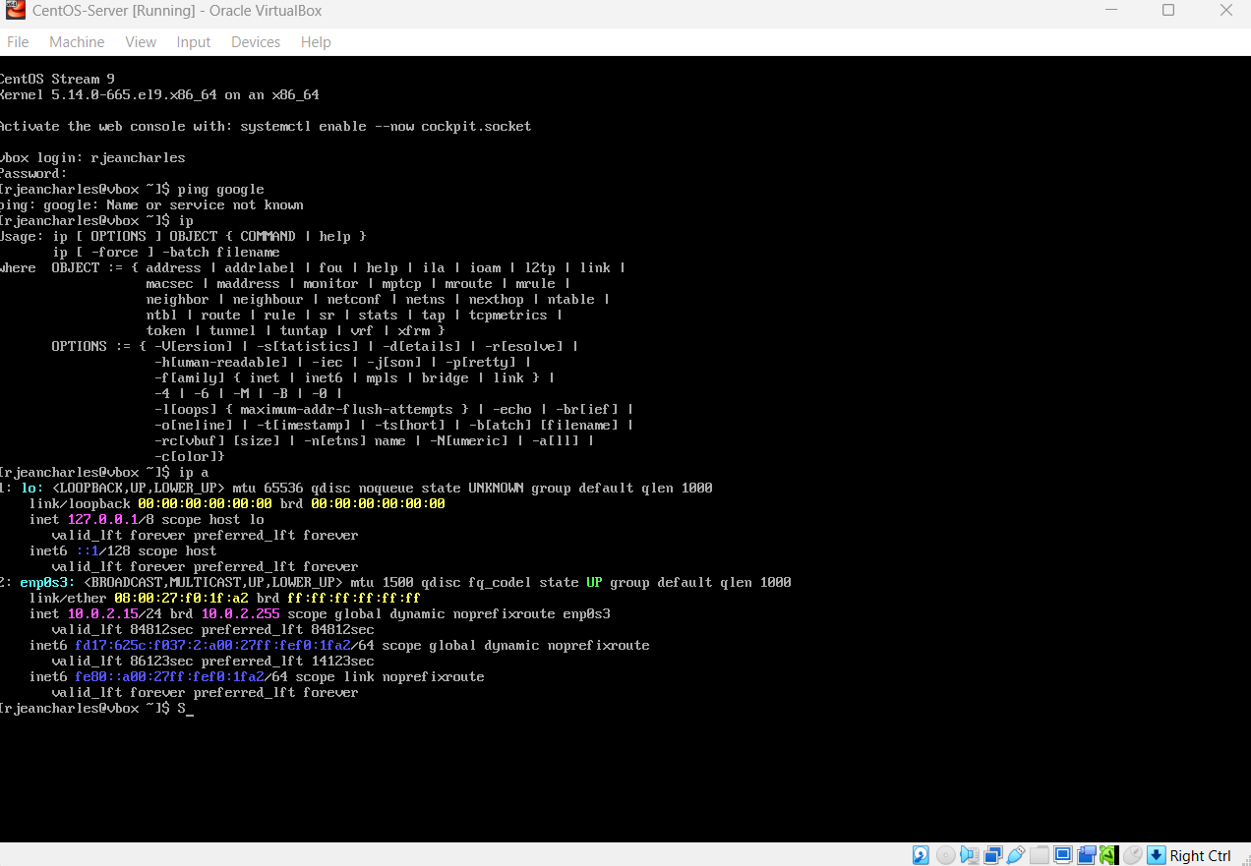
This command helps me verify the network configuration on the server. It shows the IP address that allows you to access the server from another machine.

Lab 2 Grep Command
In this lab, I learned how to search and filter for data inside files using the grep command. This skill is very important since datasets can be very large. Manual searching can take a lot of time.
I used pattern matching and regular expressions to find specific information such as phone number or name.
Command Example
grep -E “:[8][0-9]{2}-[0-9]{3}-[0-9]{4}” ‘GrepLab(1)’
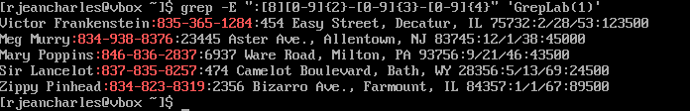
This command searches for phone numbers where the area code starts with 8.

Lab 3 Sed Command
In this lab, I learned to modify files automatically without opening them manually while using sed. It is very useful for system administrators who need to process large files quickly.
I execute tasks like replacing text, delete file, and formatting data using patterns
Command example :
sed -i '/^Sir/s/$/***/' "GrepLab(1)"
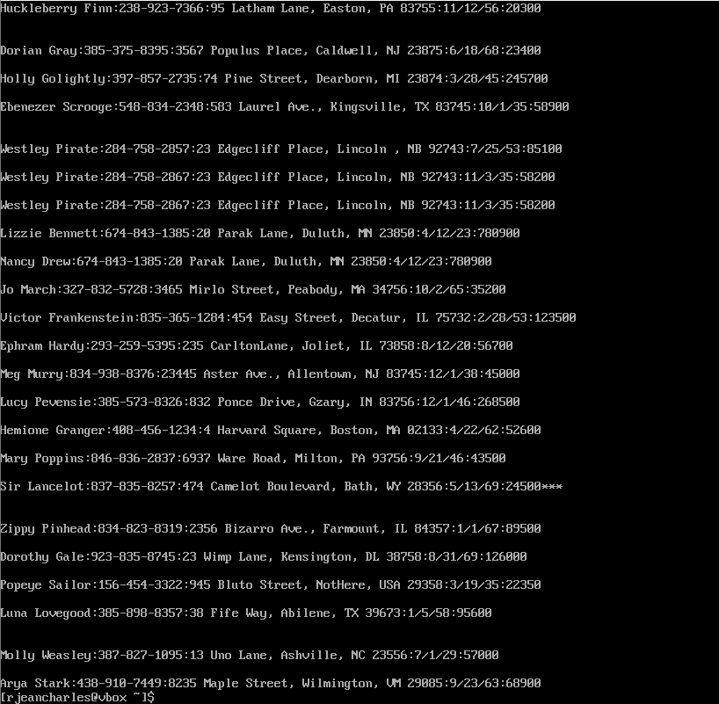
This command modifies a file by adding three asterisks at the end of every line that starts with “Sir”. This change is permanent because of -i.

Lab 4 awk Command
In this lab I learned how to process structured data and extract meaningful information. I used awk to filter records, extract field. It can perform calculation and logic unlike sed command.

Command Example
awk -F’:’ ‘{total=$3+$4+$5; print $1, “$” total} AwkLab.data
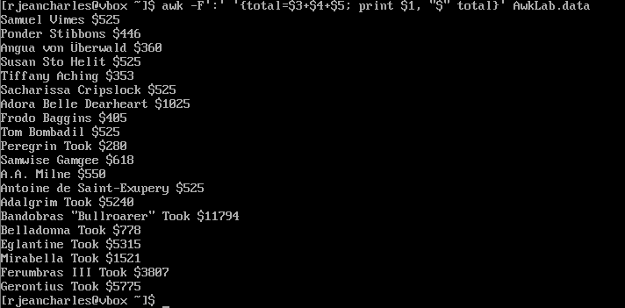
This command calculates the total contribution for each person by adding multiple columns together.

Lab 5 Software Installation
In this lab, I installed and configured essential tools on both servers. This includes utilities for productivity, monitoring, and security.
I worked with package managers like apt and dnf, installed tools such as tmux, emacs, fail2ban and cowsay.
Command example
Sudo systemctl status fail2ban
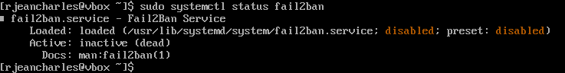
This command verifies if fail2ban service is running or not. In this case it is not running.
It should be configured manually.

Lab 6 Security Script Lab
In this lab, I focused on improving server security by creating and testing scripts on both ubuntu and CentOS servers. I used AI tools such as ChatGPT and Gemini by Google to generate initial script. I test them, troubleshoot and modify them to make sure they worked correctly.
Those scripts executed a lot of security tasks such as firewall configuration, installation of Fail2ban, system and automatic updates. While testing I face issues such as permission errors, incomplete packages and so on. I solved these problems by adjusting commands, installing dependencies, and revising scripts.

Command example
sudo ufw status verbose
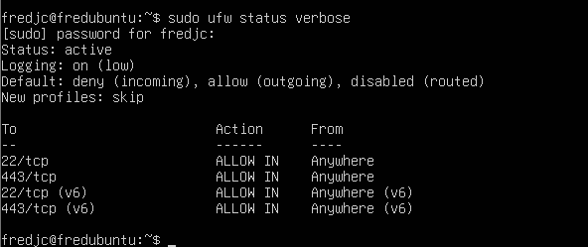
This command helps verify if the firewall is active and correctly configured. It confirms the block of unnecessary ports. It ensures that the only essential services are authorized. Overall, it helps protect the server from unauthorized access.

Skills and Tools
Operating system, Linux( CentOS, Ubuntu). System administration( user and permission management), Security ( Firewall configuration, intrusion prevention with fail2ban), Scripting( Running and test scripts, troubleshooting script errors), SSH configuration and verification, File transfer using WinSCP, PuTTY. Searching and filtering file, editing and modifying files, processing and analyzing structured data.

Accomplishment and Challenges
One of my biggest challenges is time. Even though I took resolution to spend more time on labs and I did it though. I really struggle with the continuation set up. This lab requires a lot of patience. I also deal with configuration problems such as installing dependencies. I also face issues in Security script lab. Making the scripts work was not easy task. I had denied permission. Sometimes I even have to start over.

My biggest accomplishement was when I built, configure and secure both servers that allows me to continue the other labs. I did it from scratch. I never done that before. I was able to install systems, configure network and enable remote access while using PuTTY. I also proud because I have to modify security script to make them work. Overall, I proud of myself because I develop patience, research and problem-solving skills at another level.

Conclusion
Finally, I feel ready to start any internship or job related to computer security and my interest in Cybersecurity growth. I will pursue a four-year degree, but I haven’t decided which university yet.

